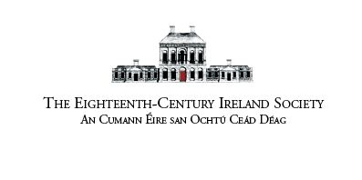 | Application for Postgraduate Bursary, Eighteenth-Century Ireland Conference, Dublin City University,  16-17 June 2023 Confidential

Closing date: 31 March 2023
Applications to be sent to: Dr Suzanne Forbes (suzanne.forbes@open.ac.uk)

1. Applicant
Surname
Forename
Tel. No. (including international code)
Email:

Name of University at which you are registered
Title of award/degree for which you are registered (e,g. DPhil, PhD, etc.)
Year of initial registration on this degree/award
Name, title and position of supervisor/s (If there is a supervisory team, please include these details for all its members.)

2. Research Project Details
(Working)Title of thesis

3. Conference Paper Proposal
Please give the (working) title of your paper and an abstract (not more than 250 words; single spaced 10 point font).

4. Significance of conference
Please explain concisely how attendance at the conference will contribute to the development and progression of your research project (not more than 250 words; single spaced 10 point font).

5. Referee (preferably your supervisor)
References may be requested if you are shortlisted for a bursary
Name:
Post/Dept:
Institution:

I confirm that the information provided in connection with this proposal is complete and accurate.

6. Signature and date
Signature:

Date:

