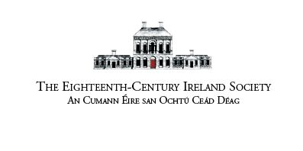
2023 Annual Conference
Dublin City University
16-17 June 2023

Preliminary Call for Papers
The 2023 Annual Conference of the Eighteenth-Century Ireland Society/An Cumann Éire san Ochtú Céad Déag is scheduled to take place as an in-person event in Dublin City University on 16-17 June, 2023.

Proposals are hereby invited for twenty-minute papers (in English or Irish) on any aspect of eighteenth-century Ireland, including its history, literature, language, and culture. The Eighteenth-Century Ireland Society is a multidisciplinary organisation and we welcome papers from all relevant disciplines, including interdisciplinary and comparative research studies. We particularly encourage early career scholars to submit proposals, as well as those working with new methodological and theoretical perspectives. Scholars wishing to form a panel for a specific theme are free to do so.

Proposals for papers and potential panels should be submitted by e-mail to any member of the Organising Committee by Friday 3 March, 2023:

Prof. James Kelly (james.kelly@dcu.ie)
Dr Suzanne Forbes (suzanne.forbes@open.ac.uk)
Prof. Ciarán MacMurchaidh (ciaran.macmurchaidh@dcu.ie)

Proposals should include: the speaker’s name, institutional affiliation, title of paper, and a 250-word abstract. A decision in relation to the proposal will be communicated to prospective speakers by Friday 5 May, 2023.

Cuirfear fáilte ar leith roimh pháipéir agus painéil i nGaeilge ar ghné ar bith de shaol agus saíocht na Gaeilge san ochtú céad déag. Iarrtar ar dhaoine ar mhaith leo páipéar 20 nóiméad a thairiscint, a n-ainm, a n-institiúid, teideal an pháipéir mar aon le hachoimre 250 focal a chur chuig Ciarán Mac Murchaidh ag an seoladh r-phoist thuas.

Postgraduate Bursaries
The Society is also pleased to invite applications for 3 postgraduate bursaries for the 2023 Annual Conference. The bursaries will cover conference registration fees and attendance at the conference dinner. Application forms with proposals for papers should be sent to Dr Suzanne Forbes (suzanne.forbes@open.ac.uk) by Friday 3 March, 2023. Successful applicants should hold valid ECIS membership at the time of the conference.

Any other informal queries should be addressed to one of the conference organisers.

The conference is being organised in association with the DCU School of History & Geography, Fiontar & Scoil na Gaeilge, DCU and the School of Arts & Humanities, The Open University.

