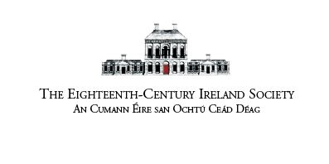

Eighteenth-Century Ireland Society/Cumann Éire san Ochtú Céad Déag
2023 Annual Conference Postal Registration Form

Title

Name

Institutional Affiliation (if applicable)

Email address

Please specify any dietary requirements (e.g. vegetarian, gluten free etc)

Please tick the appropriate registration options below:

Full conference registration

Full conference - €50 | ◻
Full conference (students, retired, unwaged) - €25 | ◻

One day conference registration

One day only - €25 | ◻
One day only (students, retired, unwaged) - €15 | ◻

Conference Dinner

The conference dinner will take place on Friday 16 June at Il Corvo, 98-100 Upper Drumcondra Road. Dinner includes a three-course set menu, half bottle of wine, and service charge. Places are limited and will made available on a first come, first served basis.

Conference Dinner - €60 | ◻

Payment

Please return this form, with a cheque made payable to ‘Eighteenth-Century Ireland Society’, to the following address before 9 June 2023:

ECIS Treasurer, Máire Ní Íceadha, Roinn na Nua-Ghaeilge, Áras Uí Rathaille, Coláiste na hOllscoile Corcaigh, Corcaigh.

