Saint Patrick’s Cathedral

Dublin

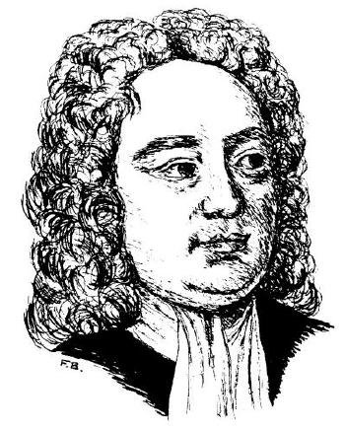

Saturday 19 October 2013

Twelfth Dublin Symposium
on Jonathan Swift

(see reverse for details)

❖        

Sunday 20 October 2013
15.15

Annual Service in Commemoration
of Jonathan Swift
Dean of Saint Patrick’s 1713–45

Address: The Revd Dr Alan McCormack

Twelfth Dublin Symposium

Saturday 19 October at 14.00

The Deanery, Upper Kevin Street, Dublin 8

Registration required

To register please telephone 01 453 9472

or email: dean@stpatrickscathedral.ie

Swift in 1713: On the Threshold of Saint Patrick’s

Speakers

Dr Aileen Douglas
Trinity College, Dublin

Dr Abigail Williams
St Peter’s College, Oxford

Professor Ian Higgins
Australian National University, Canberra

Professor Leo Damrosch
Harvard University

Professor Brean Hammond
University of Nottingham

Professor Ivo Banac
University of Zagreb, Croatia

Courtesy of the Dean of Saint Patrick's Cathedral
and the Jonathan Swift Foundation

www.stpatrickscathedral.ie

