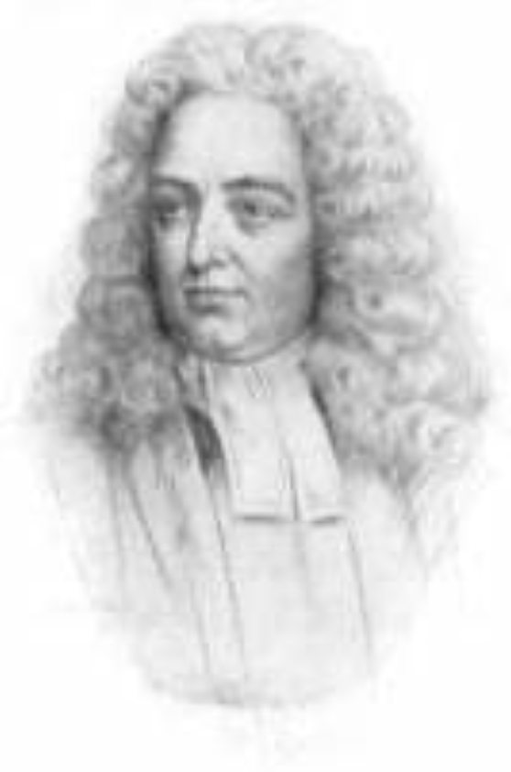 | Twelfth Dublin Symposium on Jonathan Swift,  Saturday 19 October 2013  14.00  The Deanery, Kevin Street , Dublin 8

Programme
Welcome: The Dean
Introduction: Prof. Robert Mahony (Jonathan Swift Foundation) and Prof. Claude Rawson (Yale)
Dr. Aileen Douglas (Trinity College, Dublin): “‘A gown of forty-four’: Swift and middle age”
Dr. Abigail Williams (St. Peter’s, Oxford): “ ‘Ubi nunc?’: Swift, the Journal, and the anxieties of 1713”
Professor Ian Higgins (Australian National University, Canberra): “Jonathan Swift circa 1713: The Orthodoxy of the High Church Dean of St. Patrick's.”
Professor Leo Damrosch (Harvard University): “Swift and God”
Break
Response: Professor Brean Hammond (University of Nottingham)
Observations: Professor Ivo Banac (University of Zagreb, Croatia)
Questions from the audience to the speakers

Reception and launch of new biography of Jonathan Swift by Leo Damrosch and published by Yale follows in the Dining Room

